1. Functional Deliverables:

♣ Screenshots or screen recordings showcasing: ♣

The product listing page with dynamic data.

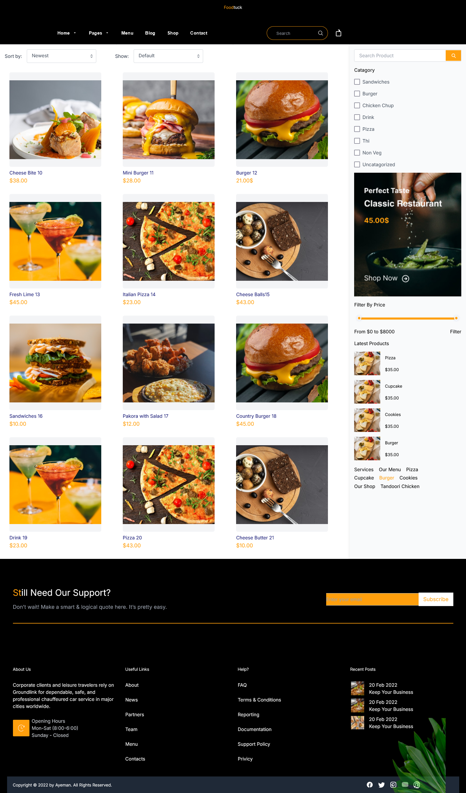

1. Code Deliverables:
2. Documentation:
3. Repository Submission: submitted on “Documents” folder on GitHub Repo.